# Wine Seller Collection

## Design and Specification

### Description

As you all know, contact manager is the most default app that any smart phones have. It is so common we cannot even imagine our life without it.

So , this cannot be considered some innovative idea that will change the world as it is thought and practices over the world around a lot of time.

**What we offer , which other don’t**

* Contact based on availability
* Contact management based on trust
* Contact based on you social status with them.
* Real time sync with online database.

**What do we use :**

* Sublime Text , Node package manager (NPM ) , Firefox Web tools for application development
* Swagger to test api , web browser to test frontend UI
* Language and Framework that were used were Node , Jquery Mobile , HTML5 and CSS3
* Storage : Real time cloud

### Motivation

Nobody even twice think of using other contact app beside the default app provided by IOS, android and other smartphone devices. Those contact are used for call, for daily transaction and for daily information exchange. Each individual has several contact on their device. Some of those contact are never even used or never even contacted once. We store so many contacts each day , looking back to past 6 month we even don’t know the person name and how they look like when we look into the contact.   
  
Rather than just saving the contacts info, our app tries to connect the emotional value regarding those contacts. So, looking back into contact will not only jog contact detail as well as memory of those person whose contact is in it.

### Summary of task

This app is just based on CRUD operation for prototype. Simply, a person can create , delete , update and edit contact info. The contact detail present are more focused on emotional value rather than the detail information.

**Future Advancement:**

* On Future, the contact information will be helped on produce to analyze based on machine learning.
* With the valuable insights presented by the analysis can be used to deduct more information about the contact
* This app can be extended as contact sharing app with emotional value attached as well.

### User case Diagrams

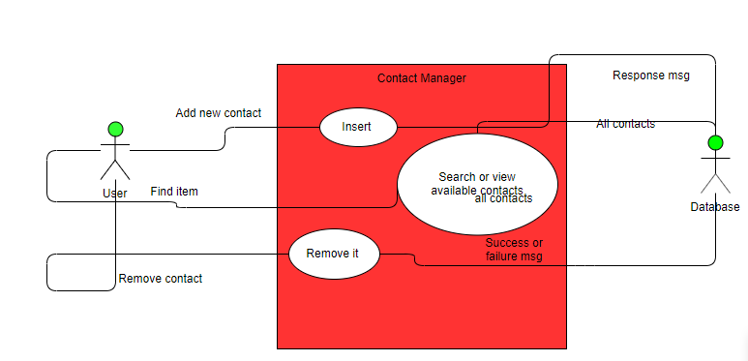

### User Interface Prototypes

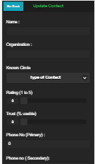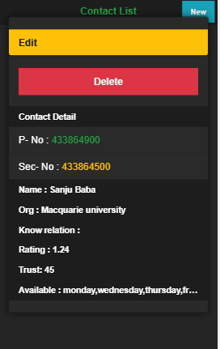

## Business Case and Marketing

### App Testing

* First static UI, based on HTML , CSS and JQuery mobile were made and tested out for UI .
* Then backend logic was written on the Node JS and tested for each module and route.
* Finally, app was tested using integration.
* All the test was subjected by developer.

**Future Testing:**

* Release the beta version of the testing to general user , take their feedback to make future enhancement as well as fixing bugs that were missed by the user.

### Research (Literature Review)

Some of the best contact management apps are :

* **Contact +**

This is the free IOS and android app, which has cloud sync feature that allows 1000 free contact and premium tier which includes increased account , syncing and business card scanning as well .

* Cardhop:

It provides natural language capabilities and language processing to search through contact. It also allows to create group , access recent contacts , and notes for each entry. It is paid IOS app with $4.99

* Sync.ME  
    
  It tries to keep contact management a simple task , pulling contact information from Facebook , Linked also updates on real time with latest profile photos and other related contact details. It is a free app.

### Business Plan

**Cost Estimation**

* **What cost for Development:**

Prototype (Man hour): 40 hours

Estimated Man hour : 90 hours

**Total development cost : 90 x $ 35 per hour = $3150**

* **Production Cost:**

MongoDB cloud cost : Starting form $65 for google cloud (USD)

Cloud Hosting Cost : $23 per year Shared hosting (USD)

App deployment to IOS : $100 per year for developer account (USD)

Play store deployment ; $25 per first time user. (USD)

* **Marketing Cost:**

Planning to facebook marketing and tv advertisement.

$4000k is separated for marketing every year.  
  
  
**For starting year the cost might be :** Nearly 20K per year.

* **Revenue generation:**

Planning to launch app with free version and in built add provided by adsense and AdMob. Expected revenue generation is $150 per year.

**Estimated Break Even Point :** 1 year 8 month based on our estimated revenue generation.

### Marketing Strategy

For marketing , in built video demo ad on TV as well as other social media. First phase , we are planning to use YouTube Ad marketing , to promote our application. Also AdMob campaign to promote our ad on other application will also be more effective to attact and increase our customer base.